**Week2-HomeAssignement-JiraAPI Testing**

**Test Scenario with Static Variable:**

1. **Create an Issue in Jira – POST request is pass**

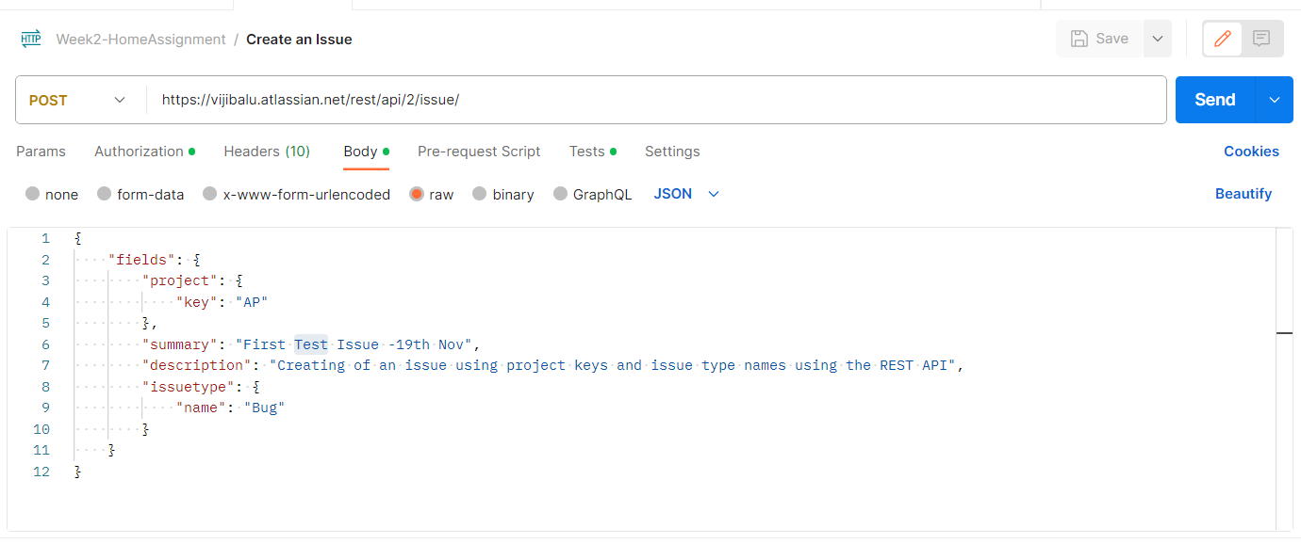

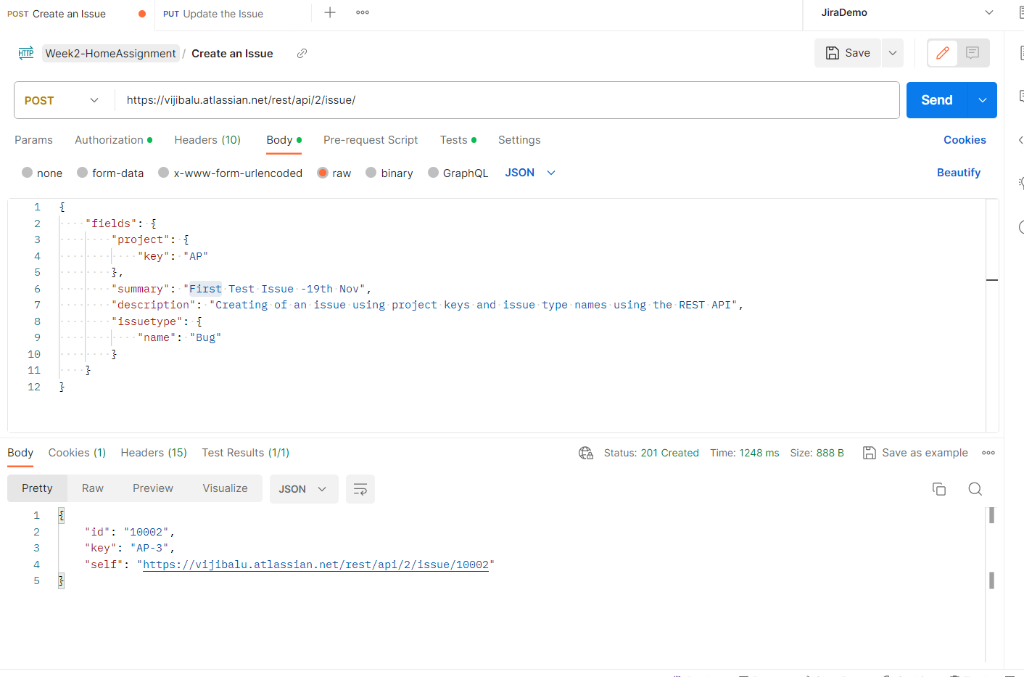

**2. Edit an Issue in Jira (Issue can be edited with Issue ID or Key) - PUT Request with static value (Key – AP3)**

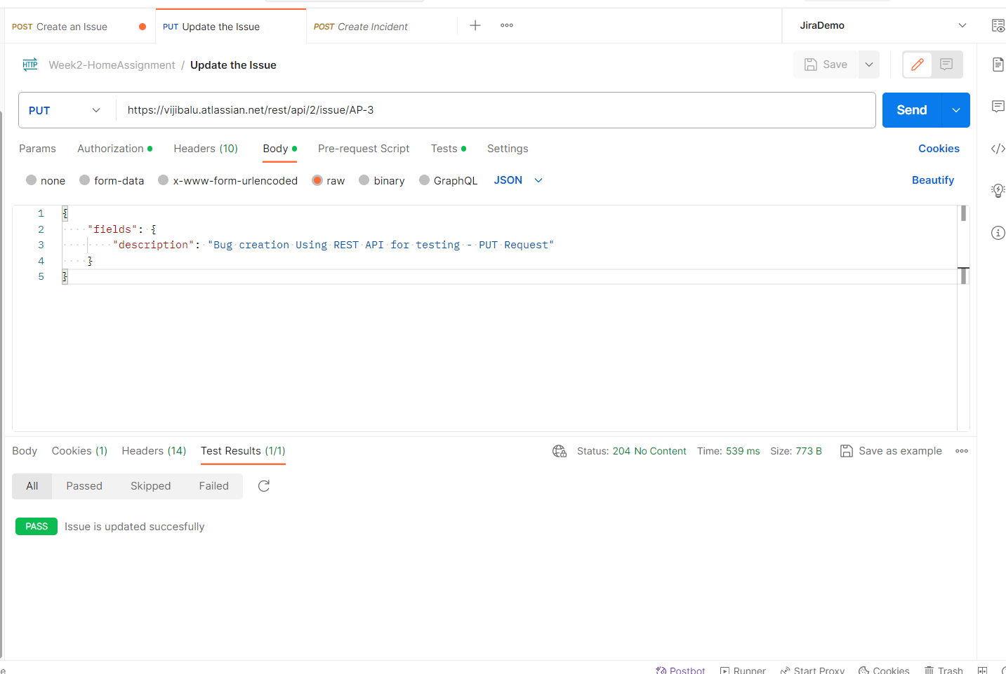

Validated in Jira and it is existing

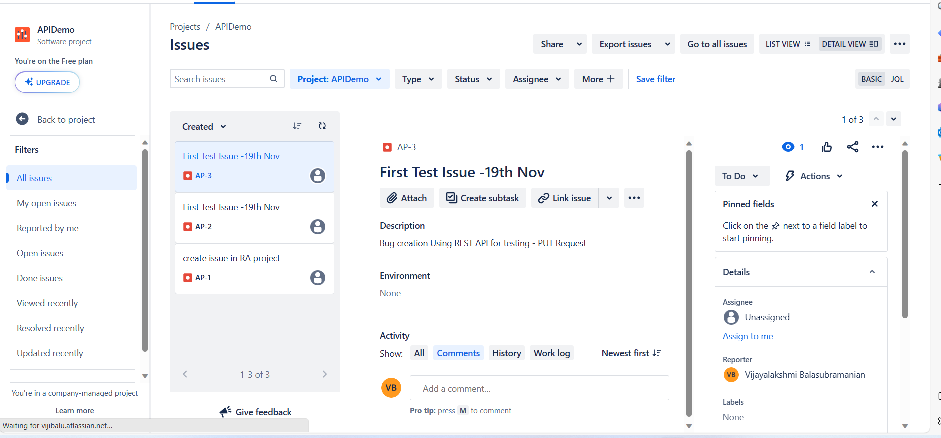

**3. Delete an Issue in Jira (Issue can be edited with Issue ID or Key) - Pass (Key –AP3)**

**Deleted successfully**

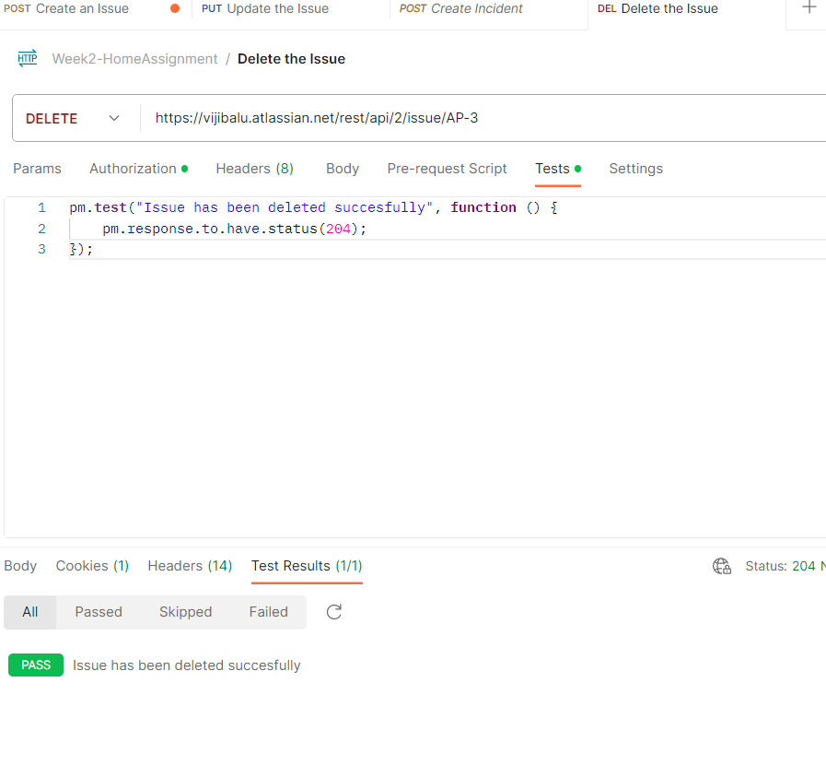

Validated in Jira and it is not exisiting

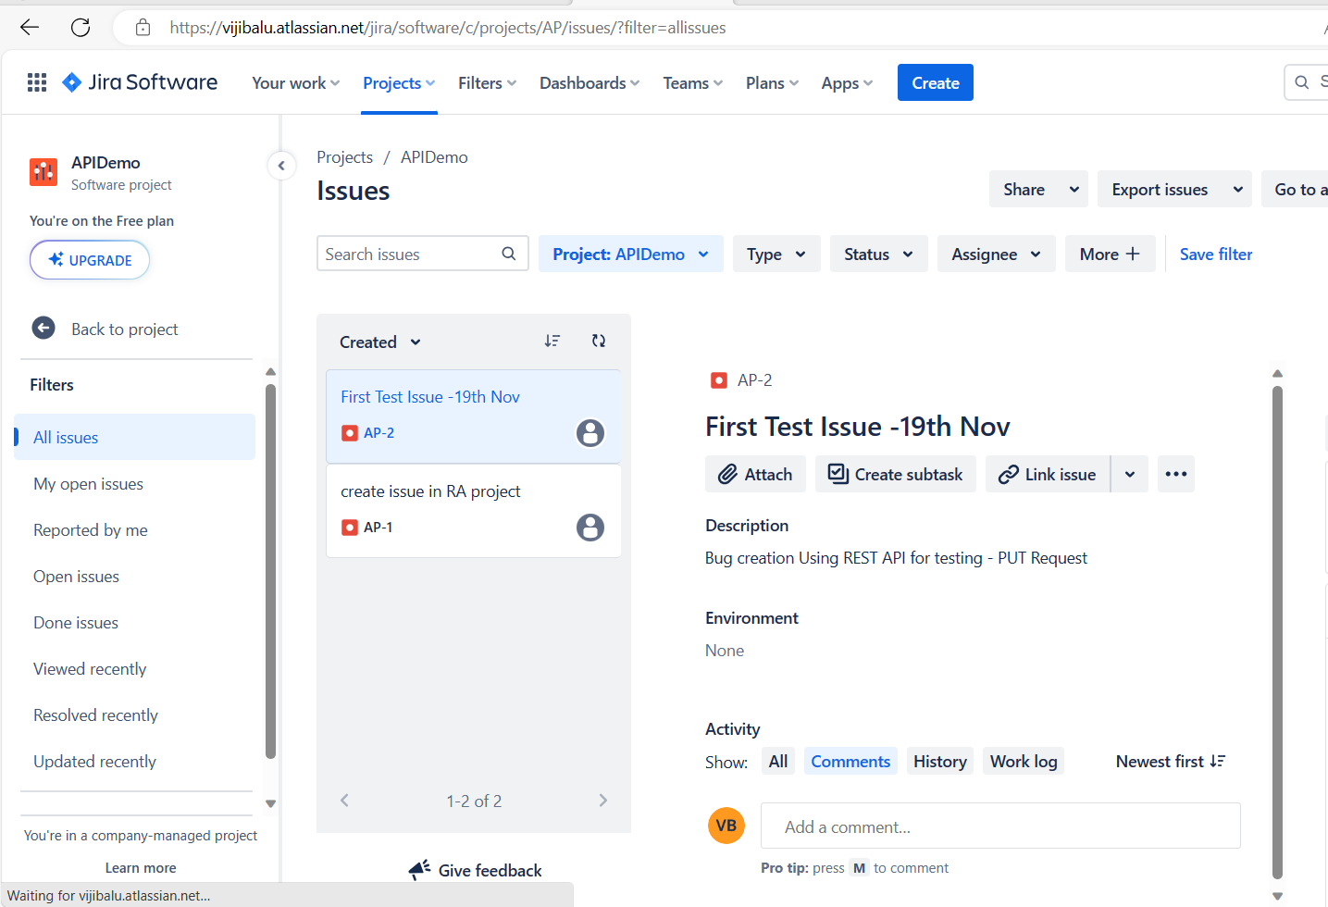

**Test Output:** Create, Update and Delete incidents in jira -Success run static variables

**Test Scenario with Chaning Requests (Global Variable):**

**1. Create an Issue in Jira – POST request is pass**

**Code snippets to set global variables**

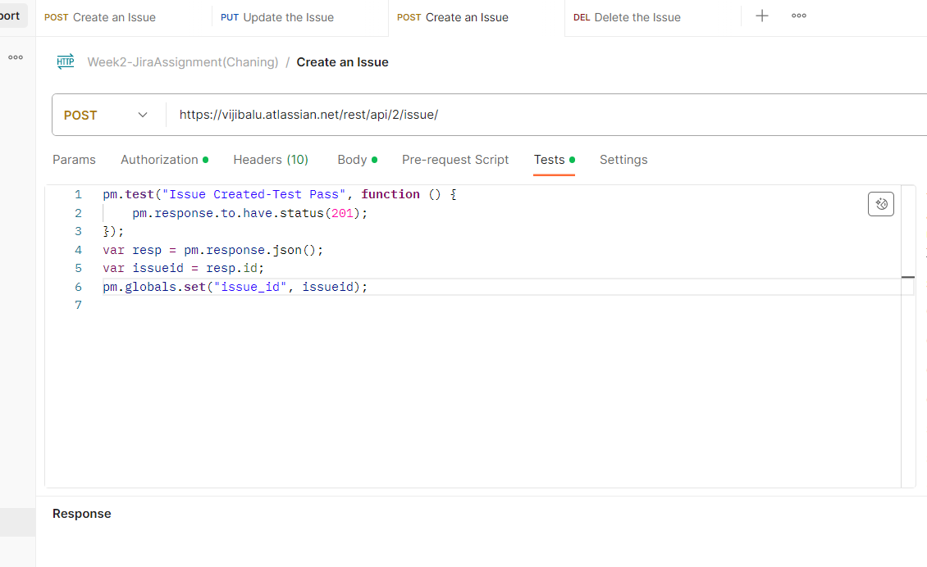

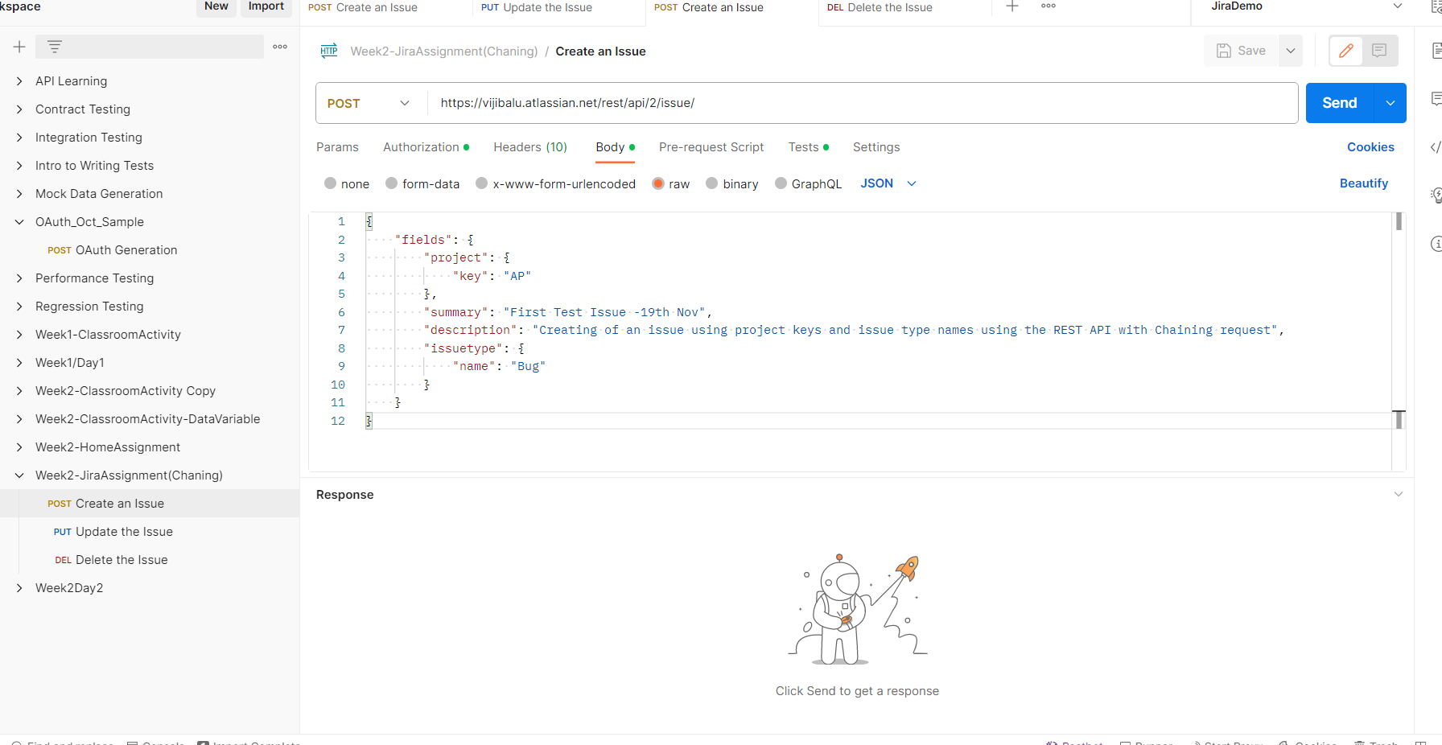

**Output:**

**Issue has been created and its Key AP-4**

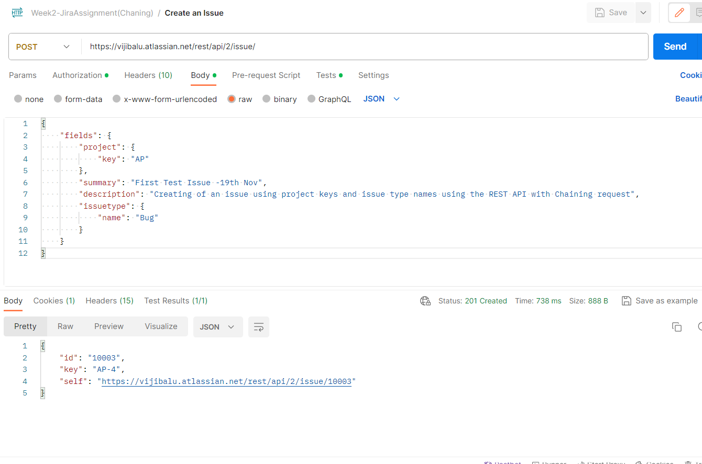

Global variable created

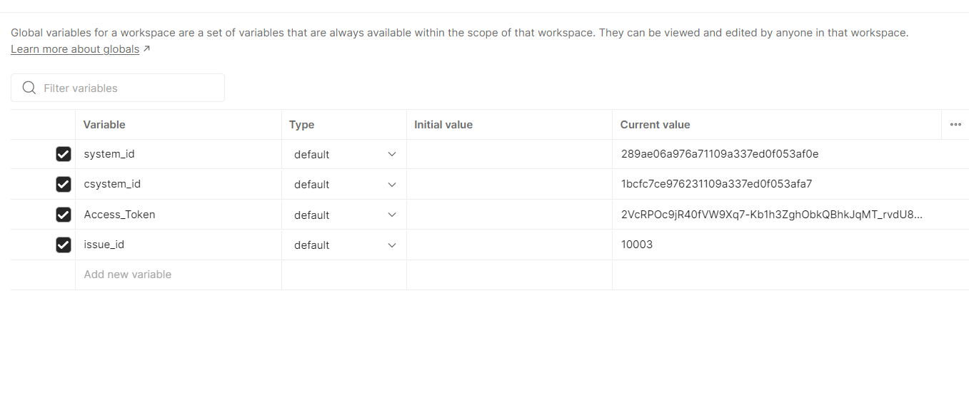

**Validated in Jira GUI and it is existing -**

**Key AP-4**

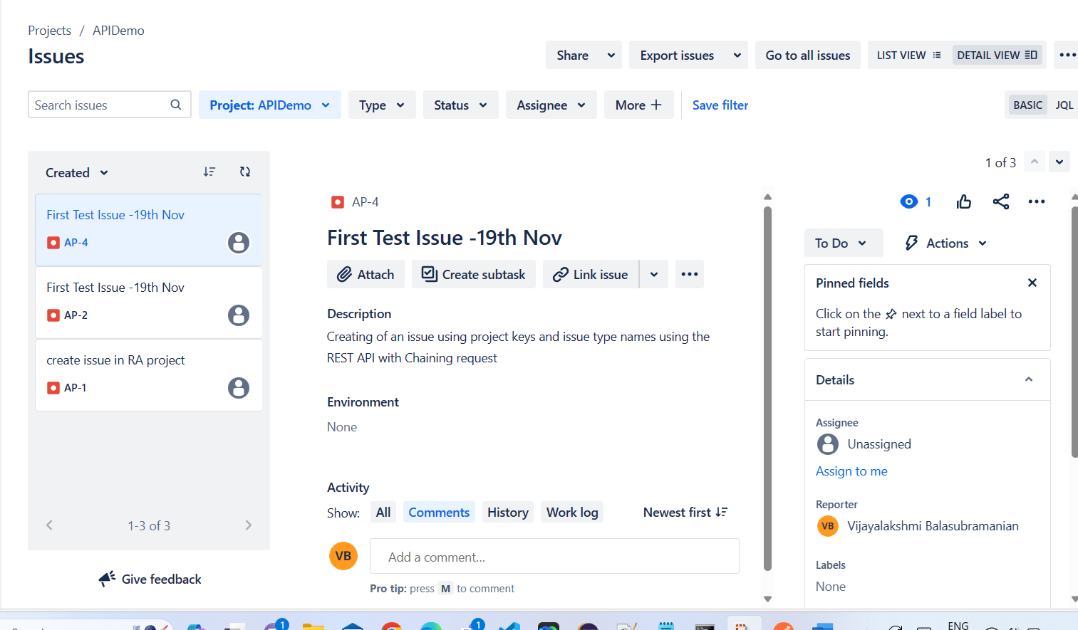

**2.Edit an Issue in Jira (Issue can be edited with Issue ID or Key) - PUT Request with static value (Key : AP-4)**

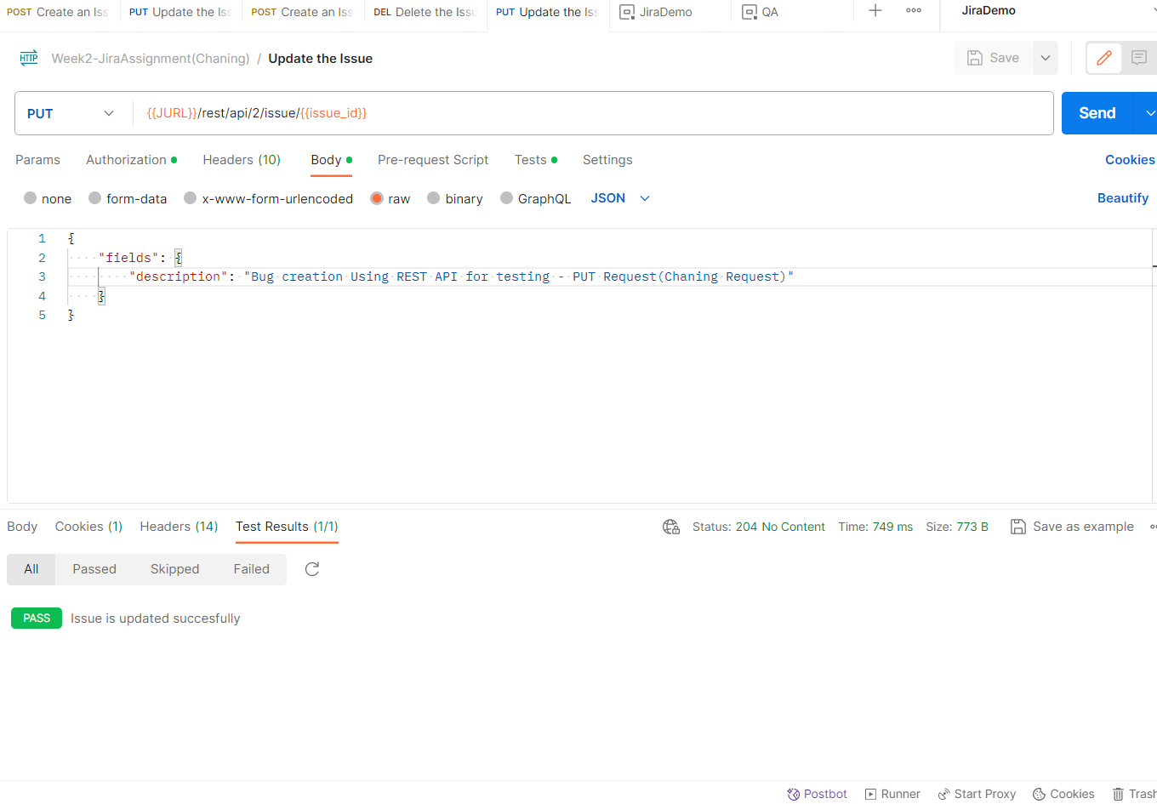

**Validated in Jira GUI and it is existing**

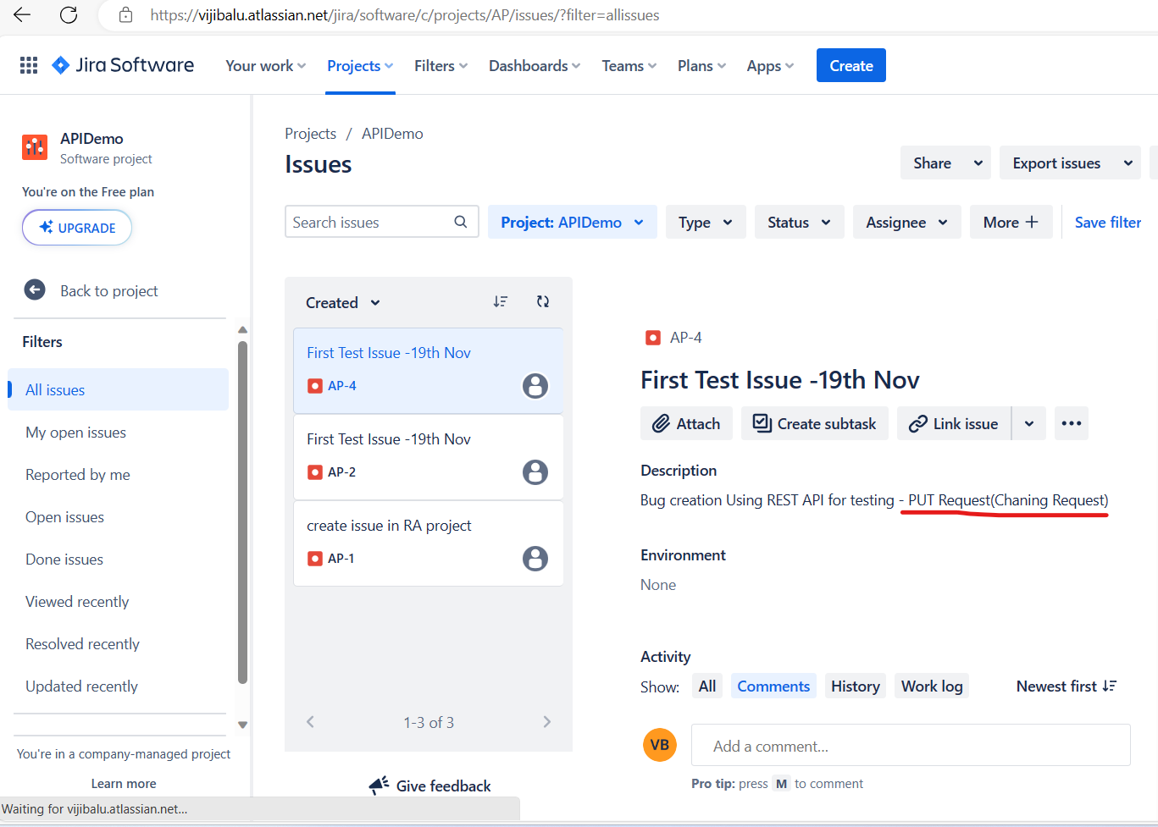

**Delete an Issue in Jira (Issue can be edited with Issue ID or Key) -Pass**

**Key AP-4 is deleted**

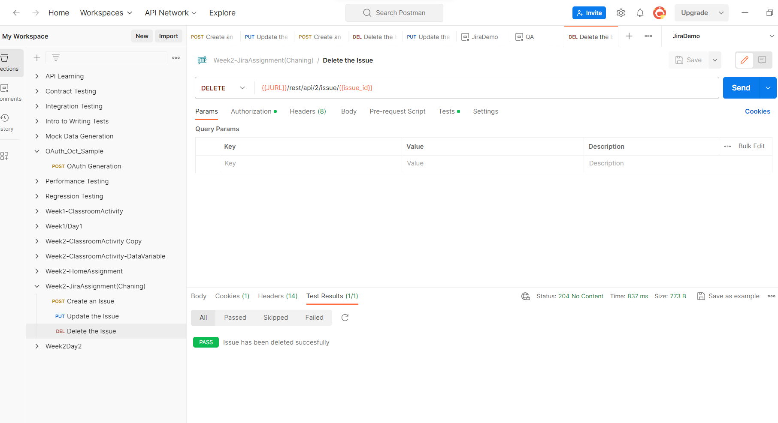

**Validated in Jira GUI and it is existing**

**Key AP-4 is not existing**

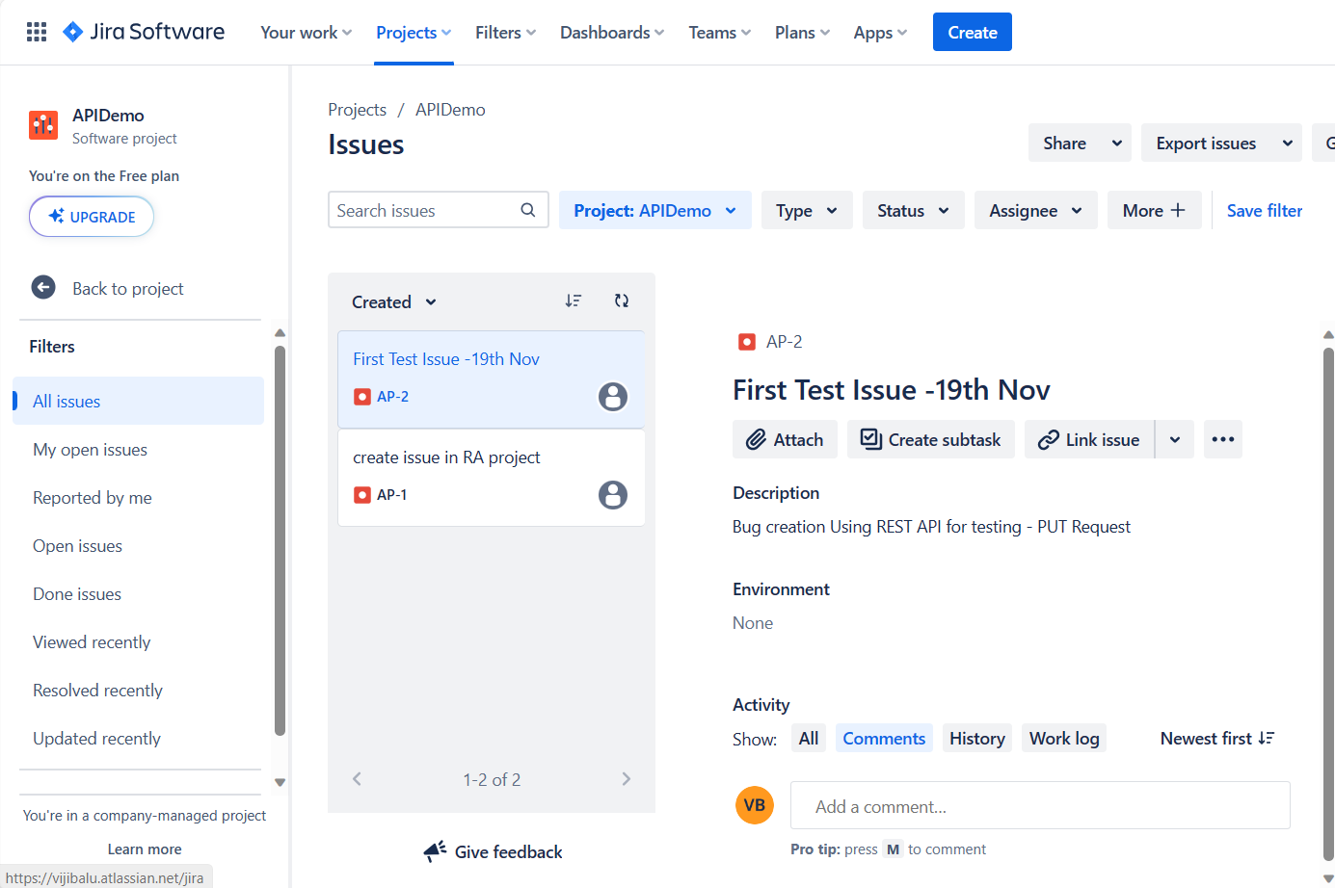

**Test Output:** Create, Update and Delete incidents in jira - Success run Chaining variables (Global, Environment)

**Test Scenario with Chaining Requests (Global Variable) - Run Collection:**

Create, Update and Delete incident in Jira with chaining of requests and executed via Run collection – pass

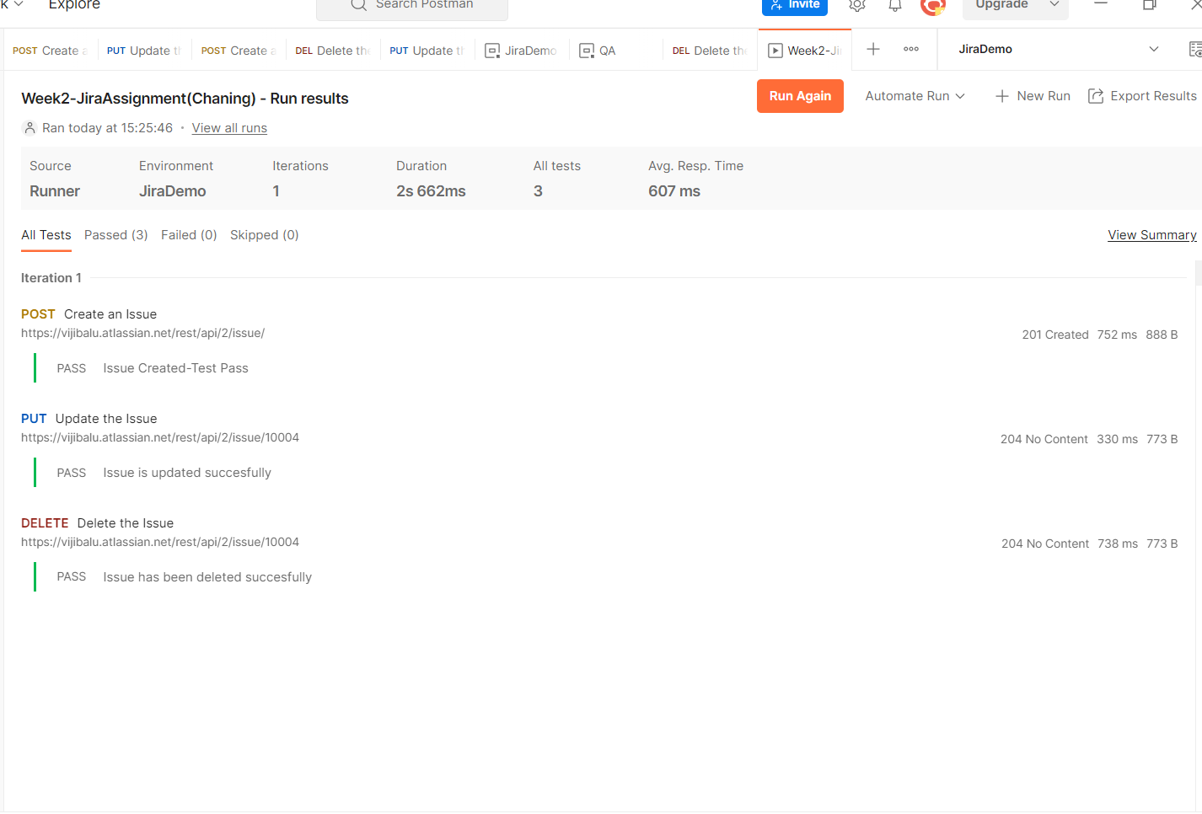

**Test Scenario with Chaining Requests (Global Variable) - Newman run without report**

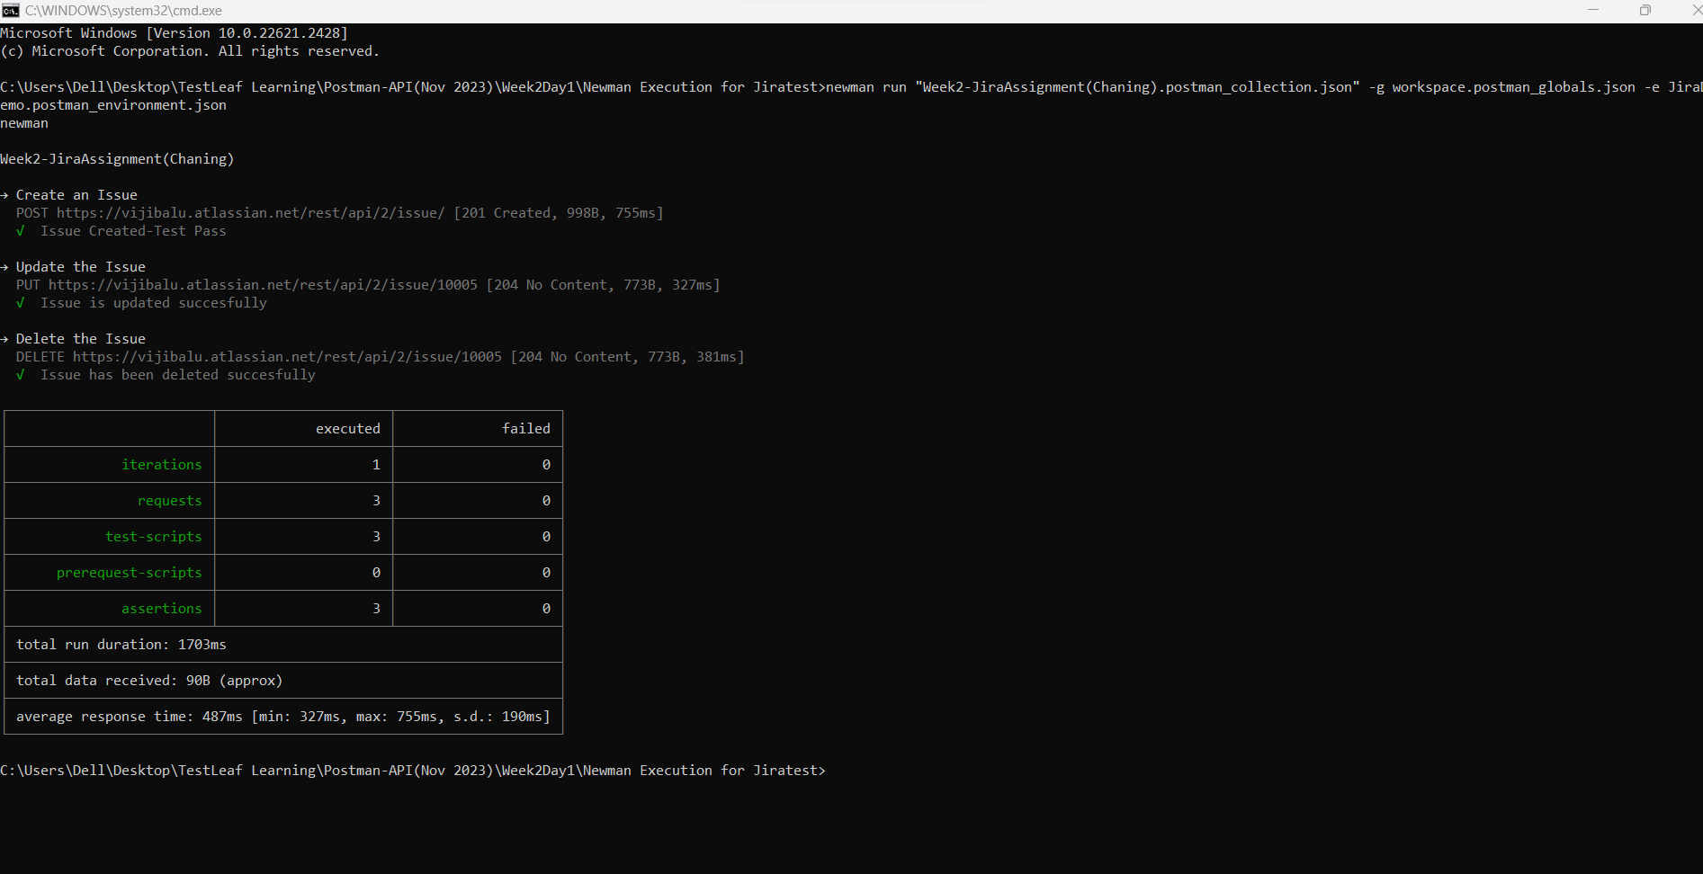

**Test Output:** Create, Update and Delete incidents in jira - Success newman run without report

**Test Scenario with Chaining Requests (Global Variable) - Newman run with html report**

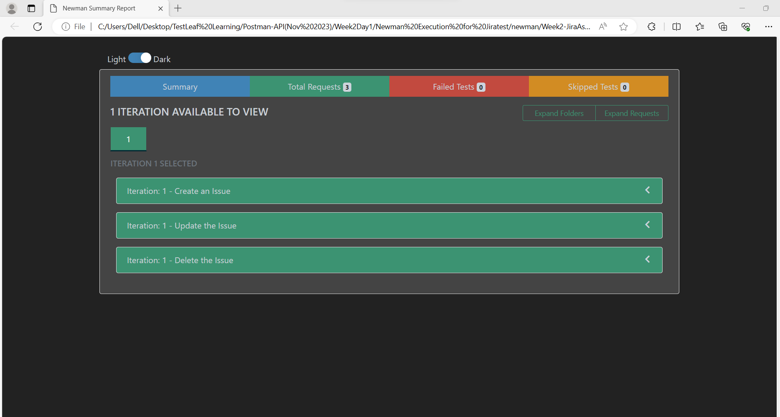

**Test Output:** Create, Update and Delete incidents in jira - Success newman run with html report

**Test Scenario with Jenkins execution**

Create, Update and Delete incidents in jira - Success with chaining of requests and executed the collections from Jenkins - Pass

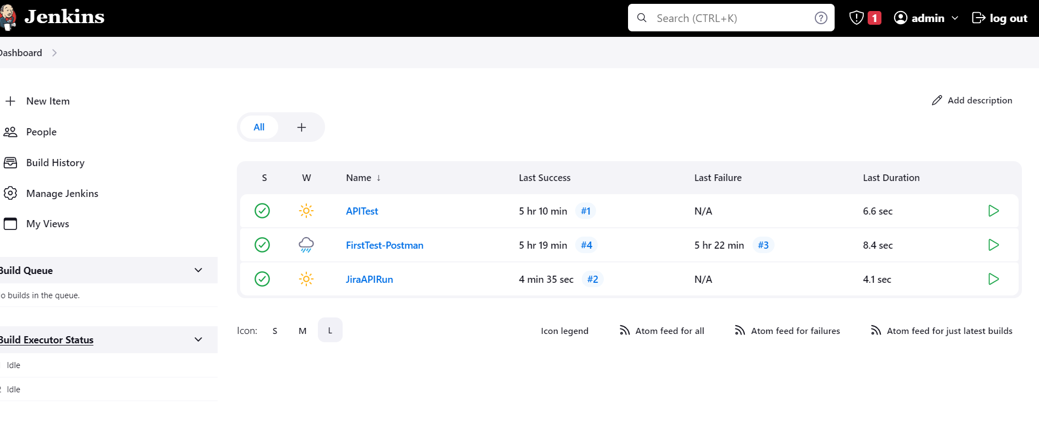

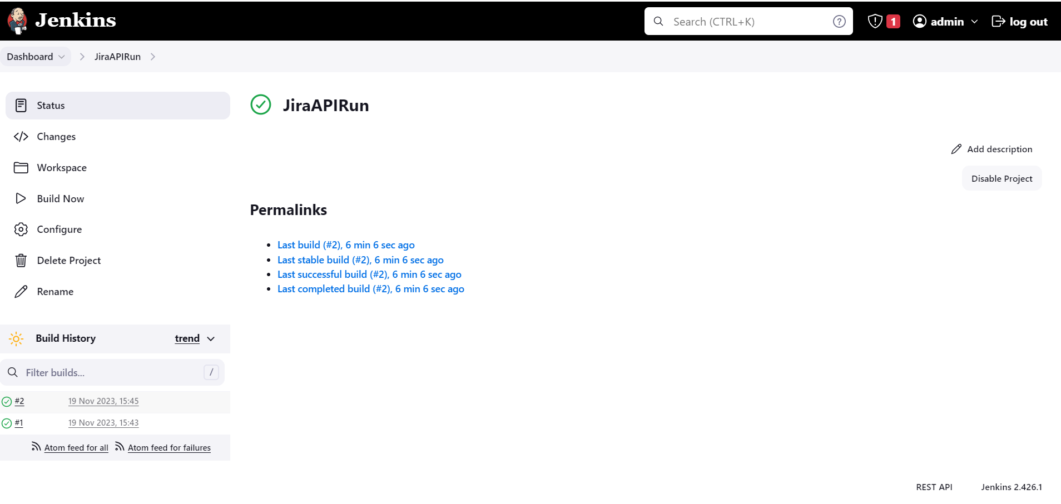

**Test Output:** Create, Update and Delete incidents in jira - Success with chaining of requests and executed the collections from Jenkins - Pass